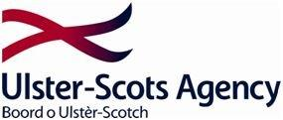

Enrolment Form

Ulster-Scots and Emigration to Maine

This course will comprise of six 2 hour sessions commencing Monday 23 September 2019. It will take place at the First Dunboe Presbyterian Church Hall, Articlave, County Londonderry

Name:
__________________________________________
Contact address:
___________________________________________
___________________________________________
___________________________________________
___________________________________________
___________________________________________

Contact telephone number: Email address:
_________________________ _______________________________
*Please not this venue has stair access to one of the halls. If this may be an issue for you in the space below please provide details in order that we can make appropriate access arrangements.
_______________________________________________________________
_______________________________________________________________
_______________________________________________________________

