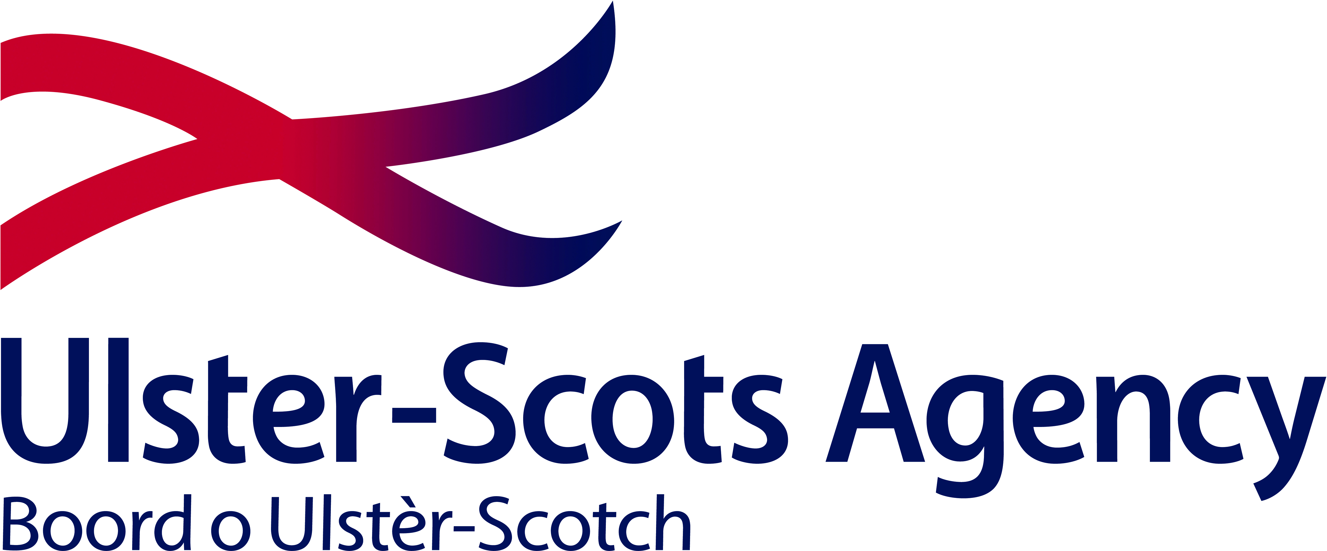
Community Festivals 2019

APPLICATION FOR FINANCIAL ASSISTANCE

Voluntary and Community Groups

Please read the Guidance for Community Festivals before completing the application form.

This form should be downloaded and filled out in the relevant areas of the form, using Microsoft Word.

Please save your application and print out a copy and sign and date by hand.

DEADLINE FOR RECEIPT OF APPLICATIONS: Thursday 25th April 2019 @ 3pm

INCOMPLETE OR LATE APPLICATIONS WILL BE REJECTED

PART 1 – ABOUT YOUR ORGANISATION

Name of Organisation:
Date Organisation formed:
Organisation Address:
Postcode:
Telephone No:
Email:

Please specify which Council area your organisation is based in:

Please specify which Parliamentary Constituency
your organisation is based in:

Has your Organisation reformed or changed its name  in the last three years? | YES NO
If yes, give details:

Please provide details of all authorised office holders within the Organisation:

Office | Name
Chairperson
Vice Chairperson
Secretary
Treasurer
Project Manager

IMPORTANT: This application form must be signed by two of the above named authorised office holders. Failure to do so will result in your application being rejected.

Details of Project Manager
Name
Position in Organisation
Address for all correspondence
Postcode
Daytime telephone number
E-mail

IMPORTANT: Please ensure that the email address listed above is correct as this will be used by the Agency as the first point of contact with your group. Please ensure that the Project Manager is fully aware of all aspects of your project as this is the individual the Ulster-Scots Agency will contact should we require further information.

Details of your Festival
Name of Festival
Estimated Cost of Festival £/€
Amount Contributed by organisation and all other sources £/€
Amount of grant being sought for the Ulster Scots Agency
Proposed start date of Festival
(day, month and year)
Proposed end date of Festival
(day, month and year)
Will your group have appropriate insurance in place to cover all activities within your programme before the start date of your festival |  | YES | NO

Festival Plan – (All Applicants must submit a Festival Plan)

Please confirm you have submitted a Festival Plan which can be downloaded from our website. A hard copy must be sent with your application and email a copy to our Grants officer JTaylor-Clarke@ulsterscotsagency.org.uk Please ensure that the budget section of the Festival Plan corresponds with Part 5 of this application.

YES □ NO □

Marketing Plan (Major Festivals only)

Please include a detailed Marketing Plan with your application. You must include information on how you will market the various elements of your Festival, including target audiences, key messages and the techniques that you will use to deliver your messages.

Please confirm you have submitted a Marketing Plan with this application

YES □ NO □

Q1 Explain how your project contributes to the following four strategic aims of the Ulster-Scots Agency (Inspire, Educate, Empower & Engage)

(Maximum 300 words)

Q2 Does your organisation currently promote Ulster-Scots within your community? Yes □ No □
If yes, tell us what your group have done in the last 12 months to promote Ulster-Scots within your community.

(Maximum 300 words)

Q3 Explain how your festival will raise awareness of Ulster-Scots Culture, Heritage and Language.

(Maximum 300 words)

Q4 Please explain how your Festival will encourage skills development and community participation

(Maximum 300 words)

Q5 Tell us how your group is managed and what experience and/or skills have you to organise a
Festival.

(Maximum 300 words)

Q6 How will your festival leverage other funding and offer value for money.

(Maximum 300 words)

Q7 Please explain how you intend to pay for the elements of your Festival that you are not asking the Ulster-Scots to fund. You should list contributions from other funders, your own group and any in-king contributions (please explain the rationale for these). Please tell us whether these contributions have been secured or you are awaiting confirmation. Remember that these need to represent at least 25% of the total cost of your Festival.

(Maximum 300 words)

Q8 Is a similar Festival already taking place in your area? If so, please further explain the need for your Festival

(Maximum 300 words)

Q9 If the Ulster-Scots Agency is unable to fund your Festival project what alternative arrangements can be put in place to proceed with your plans

(Maximum 300 words)

Q10 Tell us how you plan to promote your Festival (minor festivals only)
(Maximum 300 words)

PART 3 – MAJOR FESTIVALS

(Should only be completed by groups applying for A Major Festival)

Q11 What progress has been made with the planning of your Festival to date

(Maximum 300 words)

Q12 Tell us about the risks associated with your Festival and how you will manage them
(You may include a separate Risk Assessment if necessary)

(Maximum 300 words)

Q13 How do you plan to promote the long term sustainably of your Festival.

(Maximum 300 words)

Q14 Tell us how many spectators you expect to have at your Festival and how have you estimated
this figure

(Maximum 300 words)

PART 4 – Any Other Information
You can use Part 4 to explain the rationale behind your figures for in-kind contributions

PART 5 – Your Festival Budget

Please ensure that your budget is compatible with your Festival Plan

In-Kind Costs
Important: Although they do not involve actual expenditure, in-kind costs should be included under both expenditure and income so that they form part of the overall balance of income and expenditure for your Festival. You should explain the rationale behind your figures for in-kind contributions at Part 4 – Any Other Information

Expenditure
Please specify all proposed areas of expenditure - Show breakdown of costs.
Item of Expenditure | Amount  £ or €
Total Expenditure:

Income

Please specify all sources of proposed income.
Source | Amount  £ or €
Total Income:

Income minus expenditure:

Important: the Ulster-Scots Agency will not fund you to make a profit.

Part 6 - Safeguarding Check List for Organisations Working with Children, Young
People and Adults at Risk

Each applicant must ensure that their Safeguarding policy and procedures adhere to current legislations and best practice.

If your organisation is successful in securing an offer of funding from the Agency, you must complete a safeguarding checklist. This checklist must be completed and the group must be able to assure the Agency that they are fully compliant with legislation and best practice. Completion of the checklist is a mandatory part to acceptance of the funding. Furthermore, the Agency may request, as part of the monitoring process, that your organisation will present hard copies of your safeguarding policy for evidence.

PART 7 – Declaration
Your signature on this proposal is confirmation that:

- Your understand that the Ulster-Scots Agency may discuss your proposals with other funding institutions and/or other public sector bodies to which you applied for assistance.

- You will cooperate with any appraisal or evaluation process which may be undertaken by the Ulster-Scots Agency or anyone appointed for that purpose.

- You will adhere to the provisions of all current fair employment, equal opportunities and disabled persons legislation in force in Northern Ireland or Ireland (depending on where your Group is based) and observe the spirit of that legislation.

- You understand your obligations to retain all financial information in relation to your Festival and that these may be subject to examination by the Agency and/or Audit Office.

- You are aware that you must tell the Agency about any changes to the proposed project immediately or any change in circumstances which is likely to impact on this application including the provision of funding from other sources.

This declaration must be signed by two of the authorised office holders listed on Part 1 of this application.

I certify, to the best of my knowledge and belief, that the particulars given on this form are correct and complete.

Signed |  | Signed
Print Name |  | Print Name
Position in Group |  | Position in Group
Date |  | Date

FALSE STATEMENTS CAN RESULT IN PROSECUTION

THE INFORMATION PROVIDED ON THIS FORM MAY BE MADE AVAILABLE TO OTHER DEPARTMENTS/AGENCIES FOR THE PURPOSE OF PREVENTING OR DETECTING CRIME.

Fraud Warning

The organisation and or its representatives may be prosecuted if it knowingly provides false documents or false information or statements in support of this application for financial support. The organisation and its representatives may also be subject to prosecution if it fails to inform the Agency of the provision of any additional funding support from any source that may require a repayment of any part of a grant being provided by the Agency, under the terms of this agreement.

PART 8 - CHECKLIST

Have you completed all parts of the application form?

Part 1 – About Your Group

Part 2 – About Your Festival

Part 3 – Major Festivals (if applicable)

Part 4 – Additional Information

Part 5 – Your Festival Budget

Part 6 – Safeguarding Check List

Part 7 - Declaration

Have you included all the required supporting documentation?
Important: please refer to Guidance Notes for detailed requirements.

- Your organisation’s governing document signed and dated by the current
Chairperson

- A copy of the most recent annual accounts signed and dated in accordance with
your organisations’ governing document (The annual accounts must comply with
your governing document)

- Groups formed within the last 12 months must provide a financial statement,
showing income and expenditure from point of formation to 28th February 2019.

- A current original Bank Statement (no more than 2 months old)
An online banking statement or a bank print out is acceptable but must be
Authenticated by a bank official

- Statement of Current Financial Commitments (if bank balance exceeds £1,000)

- Rental Agreement or Evidence of Ownership of Property
(if applicable)

- 3 quotes for any element over £1,000 (if applicable)

- Festival Plan

- Marketing Plan

Under new guidance to reduce bureaucracy within the Voluntary Community Sector there is an opportunity for the organisation to upload the documents listed at 1-4 on the Government Funding Database or the organisation can still provide hard copies and the Agency will do this for them. If the Organisation chooses to upload the documents please complete the form at Annex A - the Funders’ Passport Declaration.

DEADLINE FOR RECEIPT OF APPLICATIONS:

Thursday 25th April 2019 at 3.00pm
(applications received after this deadline will be automatically rejected).

Please return completed application form to:
Ulster-Scots Agency
2nd Floor, The Corn Exchange Building
31 Gordon Street
Belfast
BT1 2LG

Or
Ulster-Scots Agency
Regional Office
William Street
Raphoe
Co. Donegal
Please note we only accept hard copies.

ANNEX A FUNDERS’ PASSPORT DECLARATION

Complete section 1 or 2 of this form.
Section 1
I hereby declare that the following documents are held on the Government Funding Database (GFD) are the most up to date and fit for purpose for this application period;

Copy of Constitution/Memorandum of association □
Copy of Audited Accounts or Financial Statement □
Rental Agreement/Lease or evidence of ownership □

OR
Section 2
I hereby declare that the following documents have not been uploaded to the GFD for this application period but are now provided with this application:

Copy of Constitution/Memorandum of association □
Copy of Audited Accounts or Financial Statement □
Rental Agreement/Lease or evidence of ownership □

I agree these documents may be made available to other public sector funders via the
GFD Y/N

I also accept that this information may be published by the Ulster Scots Agency.
I understand that the Ulster Scots Agency can at any time ask to see any of these
documents.

Signed....................................................... Authorised Officer

Signed......................................................... Authorised Officer

Festival Plan 2019
Name of Organisation __________________________

Date | Name of Event | Venue | Performers | Start Time | Finish Time | Duration | Exp  Audience | Budget Cost  as per Application

