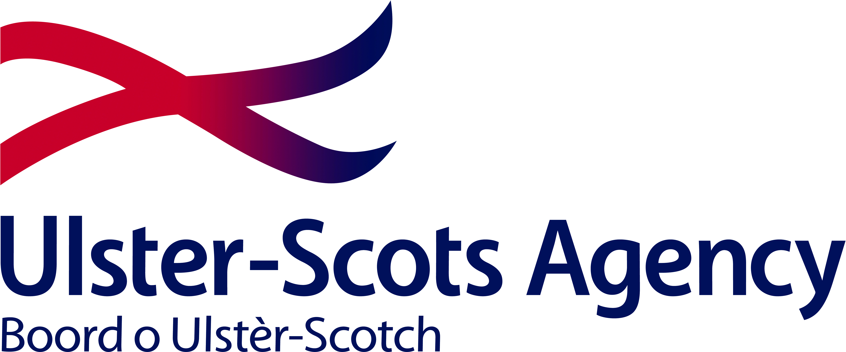

ULSTER-SCOTS FLAGSHIP SCHOOLS PROGRAMME - REGISTRATION OF INTEREST
Ulster-Scots Flagship School Programme available from November 2012
Name of Contact Teacher
School Name
Address
Postcode (NI)
Telephone No.
Email

